35.14: Using Eq.35.6 for small angles,
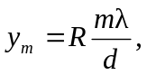
we see that the distance between corresponding bright fringes is
